**OUTREACH SCHOOLS EXAMINATION BOARD**

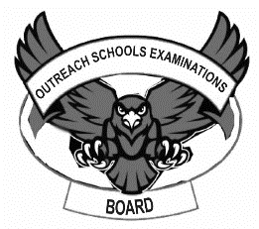 **END OF TERM II EXAMINATION 2024**

**MIDDLE CLASS: (4 – 5 YEARS)**

**LEARNING AREA 2: LANGUAGE DEVELOPMENT 1**

**My name is: ………………………………..………………………….**

**My School is: ……………………………..……….…………………..**

**I am in: ………………………………..…………………………………………..**

1. **Name the pictures.**

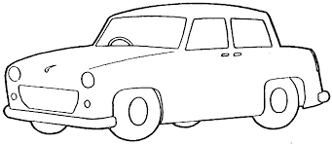**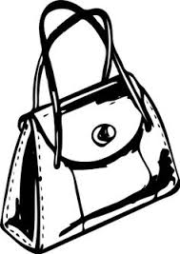________ _________**

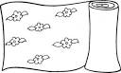 **_________ I0_________**

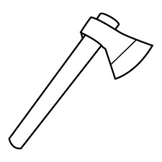**_________**

**(ten , mat , car , bag)**

1. **Match letters to words and write.**

a hat_________

c gun_________

d fan_________

e egg_________

f dog_________

g car_________

h axe axe

1. **Fill in the missing parts.**

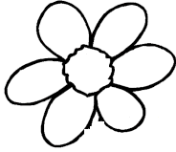 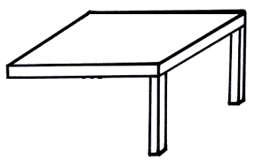

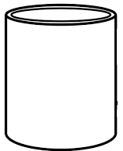 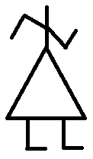

1. **Read and draw.**

|  |  |  |
| --- | --- | --- |
| **hat** | **cat** | **key** |
|  |  |  |
| **fan** | **cup** | **jug** |
|  |  |  |

1. **Circle the odd man out.**

  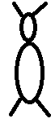  

**   **

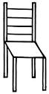

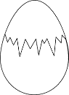   ** **

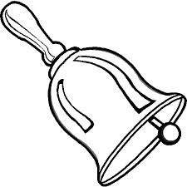

**END**